**Tattle Vs. Telling**

**What’s the Difference?!**

[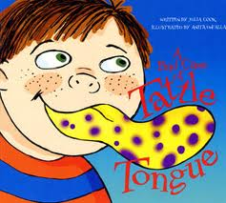](http://2.bp.blogspot.com/-gMhpPE2M7F4/T38IZI0e-KI/AAAAAAAAALA/wJAs4-vBQlo/s1600/bad+case+of+tattle)

|  |
| --- |
| **Telling**  **(write words or draw pictures to describe when you should tell an adult about a problem)** |
| **Tattling**  **(write or draw pictures to describe what it means to tattle on another person)** |